Defect (Bug) Report

**Title:** KJV BIBLE- Play Button is not Functioning

**Date:** 30/06/2021

**Device**: Infinix HOT 8 lite

**Os Version**: 8.1.0

**Screen Resolution**: 720 x 1600 px

**Project**: KJV BIBLE Mobile Application

**Description:**

ID – 001

**Steps to Reproduce:**

1. Navigate to KJV BIBLE mobile app
2. Click on Old Testament
3. Choose any Bible Chapter and Verse
4. Click on the Play button
5. Observe the bug

**Screenshot:**

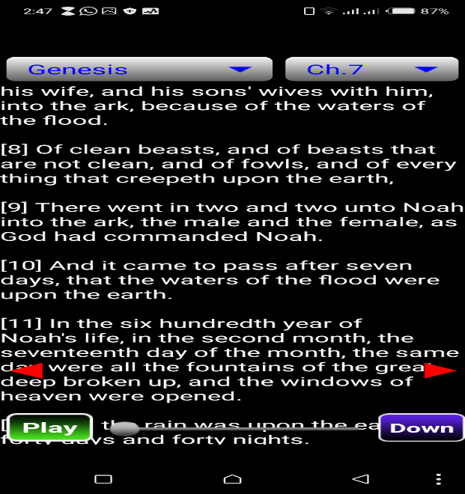

**Bug severity**: High

**Comment**: No comment

**Title:** KJV BIBLE- Download Button is not Functioning

**Date:** 30/06/2021

**Device**: Infinix HOT 8 lite

**Os Version**: 8.1.0

**Screen Resolution**: 720 x 1600 px

**Project**: KJV BIBLE Mobile Application

**Description:**

ID – 002

**Steps to Reproduce:**

1. Navigate to KJV BIBLE mobile app
2. Click on New Testament
3. Choose any Bible Chapter and Verse
4. Click on the Down button
5. Observe the bug

**Screenshot:**

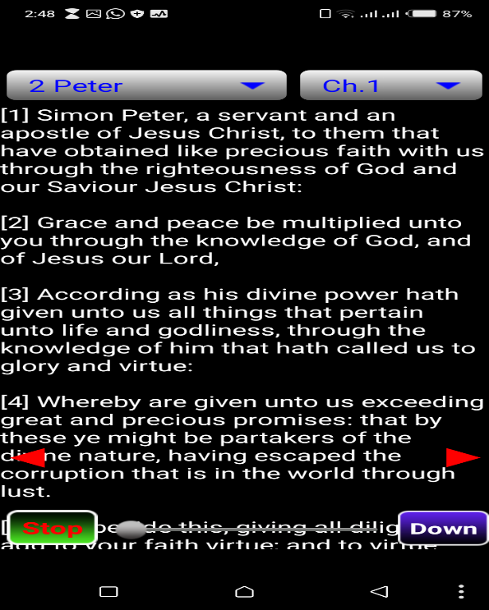

**Bug severity**: low

**Comment:** No comment